Getting Started – Pairing

Your average Smart Phone has GPS accuracy of around 30 feet.
The Android TDC100 has GPS accuracy of around 12 feet.
A Smart Device paired with the Trimble R1 has GPS accuracy of around 3 feet.

Pairing your smart device with the Trimble R1

- Put the Trimble R1 into Pairing Mode
  - Hold the power button until the left button starts blinking BLUE – it will go through a series of colors

- Turn the Bluetooth on for your smart device:
  - Go to Settings > Bluetooth > turn On
  - Under “Available Devices” select the GNSS device to “Pair it” with the R1
    - If the GNSS device is not found, try turning Bluetooth back off & back on
    - If it’s still not found, hold the power button on the R1 till there is 1 red light, and let go to turn it off. Then start back at step 1)
  - Now that your device is paired with the R1, you should not have to go through this step again, unless you are Pairing the R1 to a different device.

- Open the GNSS Status App, it should look similar to this:
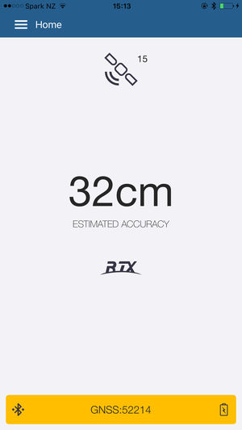

- Now click on the Big Yellow Button at the bottom, it should say “Location Services”
- Under Position Source, click Please select…
- Click Bluetooth
- It should now show Available Devices – and list the GNSS device

- Click the GNSS device
- On the bottom, click the Big Blue Button that says Select
  - The Big Yellow Button should now display the GNSS device name
- You should now see your Estimated Accuracy drop, and eventually you will see SBAS along the bottom.

Continue > Only after you have the R1 properly paired up, and your GNSS Status Accuracy is below 5 feet.
- Minimize the GNSS Status App (leaving it on) by clicking the Home button on your smart device.
- Now open the Collector app
- Sign in to Collector
  - If you are using an Android device, you will need the url to your online map
    - If you don’t know it, ask an ORWA employee, or email me at joe@ohioruralwater.org, and I will get it for you.
  - Now enter the Username & Password that was established when you activated your ESRI account
    - If you don’t know it, ask an ORWA employee, or email me at joe@ohioruralwater.org, and I will get it for you.
- Once logged in, you should see your System Map – Do not open your map yet
- Open Settings
  - On Apple – click the icon on the top right, and select Settings
  - On Android devices – click the icon on the bottom right and select Settings
- Find the Provider setting – and click on it
  - On Apple it is Provider
  - On Android it is Location provider
  - It should say Integrated Receiver, and have the GNSS device below it
- Click on the GNSS device to switch to the R1’s GPS
- Now exit the Settings, and Open your System Map
- Once the Map has finished loading, look at the accuracy in the bottom left corner to confirm that you are getting enhanced accuracy. If it is not below 5 feet, it is not working properly.

