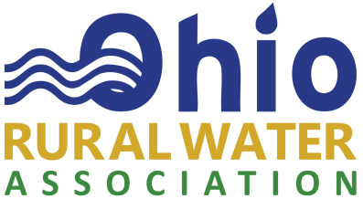

Complaint Reporting and Resolution Policy

The Ohio Rural Water Association adheres to the highest standards of conduct and ethics and is committed to investigate any complaints of suspected fraudulent or dishonest use or misuse of its resources, property, its programs and services.

All individuals associated with Ohio Rural Water Association are encouraged to report suspected activity or actions that violate established rules, regulations, laws, procedures, policy or actions of improper conduct and ethics associated with ORWA programs and services.

Reporting: The complaint should be reported in writing: to the ORWA Executive Director or to the President of the ORWA Board of Directors (if a board member or complaint involves the Executive Director). Alternately, if the reporter wishes to remain anonymous, a written statement to that effect must be included in the complaint.

Investigation: All relevant matters, including suspected but unproved matters, will be promptly reviewed and analyzed, with documentation of the receipt, retention, investigation, and treatment of the complaint. A written response of receipt will be provider to the reporter (unless anonymous) within (10) days of when the complaint was made and where appropriate, a non-privileged summary of the findings of the complaint investigation or progress in the investigation will be provided within 30 days of receipt of the complaint. Appropriate corrective action will be taken, if necessary, and findings may be communicated to the reporting person and his or her supervisor, if appropriate. Investigations may be conducted by independent persons such as auditors and/or attorneys.

No Retaliation: No individual who in good faith reports a suspected violation within the scope of this policy shall suffer harassment, retaliation, or adverse employment or other consequence. An employee who retaliates against someone who has reported a violation in good faith is subject to discipline up to and including termination of employment. This Policy is intended to encourage and enable employees and others to raise serious concerns within the organization prior to seeking resolution outside the organization. The Policy is in addition to any non-retaliation requirements contained in the ORWA Employee Policy Manual or required by law.

This protection from retaliation is not intended to, and does not, prohibit supervisors from taking action, including disciplinary action, in the usual scope of their duties and based on valid performance-related factors. Individuals making complaints must be cautious to avoid baseless allegations; employees who intentionally make false allegations are subject to disciplinary action in accordance with the ORWA Employee Policy Manual.

As approved by ORWA’s Board of Directors on 2/25/2020

