Designating Essential Employees and Service Providers
Ohio EPA has received questions regarding essential employees and suppliers/contractors that may be vital to ensuring water and wastewater facilities continue operating during periods of emergency.
Ohio EPA would provide the following guidance:
Municipal systems (village, county and city) should have a process in place to designate essential employees and provide credentials identifying them.
Utilities should review their contingency plans and identify material suppliers, labs, contract operators, etc. that are essential to ensuring the continuing operation of water and wastewater facilities. Once identified, utilities should reach out to those suppliers and ask them to join the Ohio Public Private Partnership(OP3) by going to the following weblink : https://homelandsecurity.ohio.gov/op3.stm and clicking the link to join the partnership. The location is demonstrated in the screenshot below.
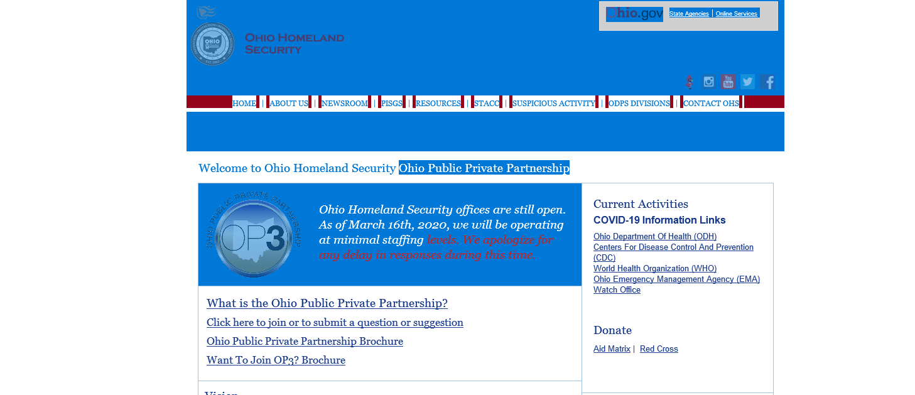

In the event of an emergency declaration that limits travel, membership in the partnership will give the suppliers, labs, certified operators, etc. the ability to request approval and credentials as essential to the treatment of water or wastewater. These credentials will allow them to continue to provide the services necessary to keep water and wastewater facilities functioning.
Private utilities, contract operators and Water and Sewer Districts should take the same steps outlined above for joining OP3.

