Getting Started – Applications

You will need up to 3 Apps, depending on if you are using an Apple or Android device. If you have a smart device, and it’s not Apple; it’s most likely an Android.

The 3 Apps Are:

ESRI’s Collector App Trimble’s GNSS Status Trimble’s GNSS Direct
(Android Only)

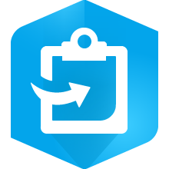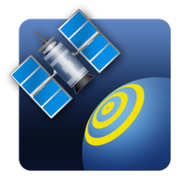

On Android Devices, you Open the Google Play Store, and search for + install the apps listed above.

On Apple Devices, you Open the App Store, and search for + install the apps listed above.

