Getting Started - Using Collector

The Collector App will look different, depending on if you are using an Android or Apple device.

Apple Interface Android Interface

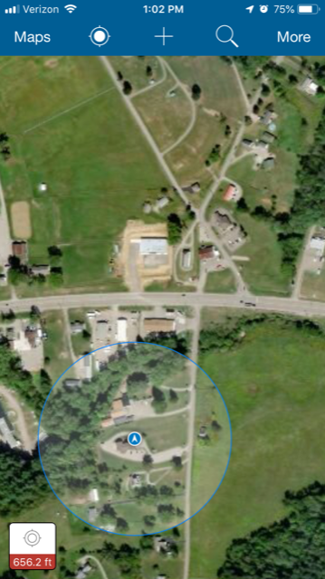

Quick Reference Guide for Collector on Apple devices:
https://doc.arcgis.com/en/collector-classic/ios/collect-data/quick-reference.htm

Quick Reference Guide for Collector on Android devices:
https://doc.arcgis.com/en/collector-classic/android/collect-data/quick-reference.htm

Collecting Assets Tutorial – Apple devices:
https://doc.arcgis.com/en/collector-classic/ios/collect-data/collect-tutorial.htm

Collecting Assets Tutorial – Android devices:
https://doc.arcgis.com/en/collector-classic/android/collect-data/collect-tutorial.htm

